AM000-Asia-Japan-Mirror-Edo-Cranes and Turtle low relief

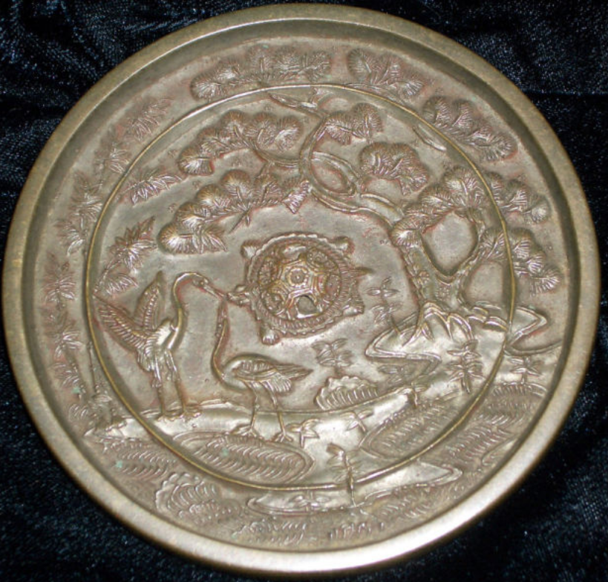

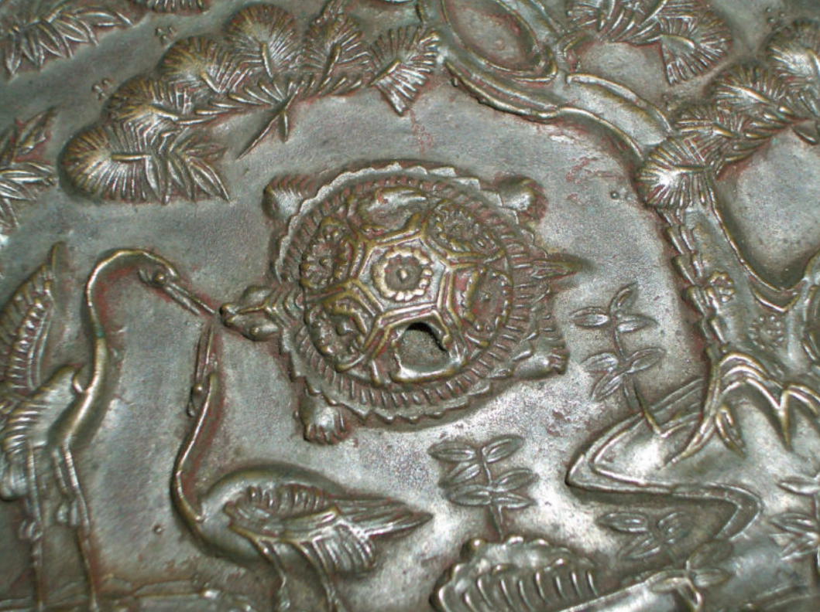

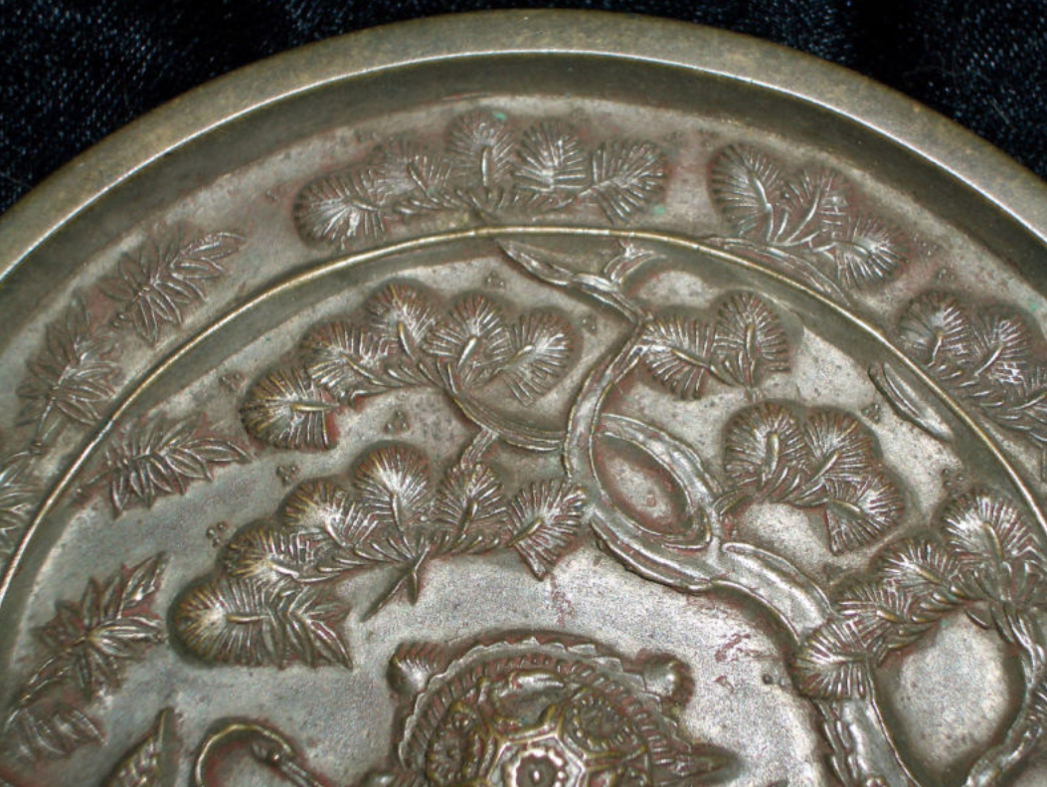

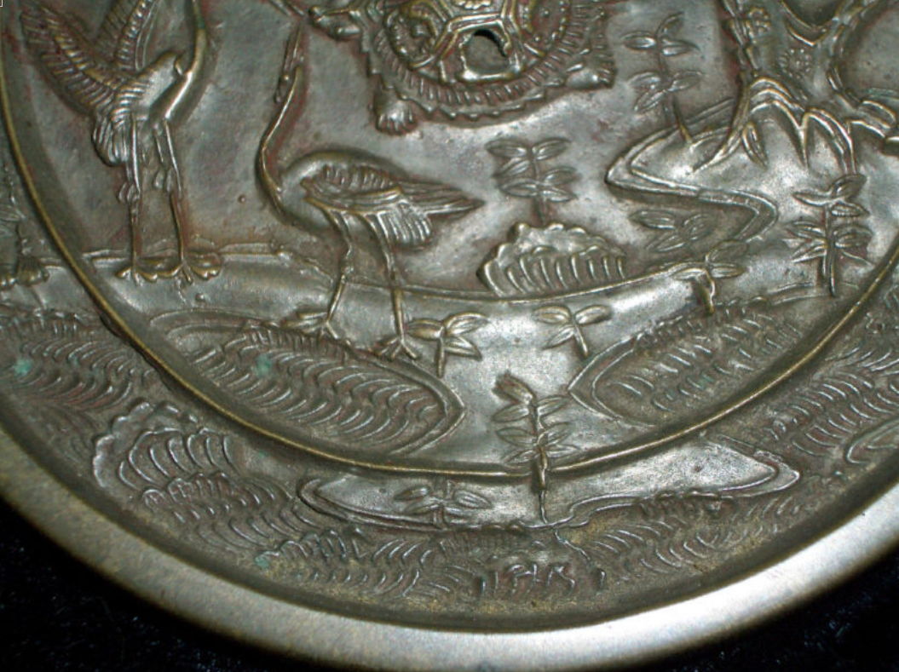This is an exquisite Japanese EDO Period (1615-1869) bronze mirror in excellent condition and shows the classic storks and turtle meeting nose to beaks symbolizing good fortune and prosperity.It has a deep golden bronze patina with only small scrathes on the mirror surface.The mirror surface still retains a polished surface.It measures 112mm in diameter and weighs 329 gm.The casting is excellent quality with very minute detail.A very nice high quality piece most certainly owned by a person of above middle class status.These mirrors were passed down from generation through generation of a family as heirlooms.These were considered a symbol of wealth and prosperity